READIFY
Smart Digital Book Reader System

Submitted by:
Yashaswi Anil Rao | Yashwanth Raj KS
1RVU23BSC177 | 1RVU23BSC180

B.Sc (Hons) Computer Science, RV University

Under the Guidance of:
Shankar M

ABSTRACT

Readify is a full-stack web application designed to make online reading more engaging and interactive. It allows users to explore books, read them online, submit reviews, rate them, and track their reading history — all in one place.
The system ensures a seamless PDF reading experience, secure login, and community-driven feedback. Built using HTML, CSS, JavaScript, Node.js, Express.js, and MongoDB, it provides an efficient and scalable structure that enhances the digital reading experience.

INTRODUCTION

With the rise of digital content, reading habits have shifted from physical books to online platforms. However, many existing systems fail to offer personalization and engagement features.
Readify bridges this gap by introducing an integrated digital reader that tracks history, displays reviews, and enables ratings — promoting a social and user-friendly reading experience.

PROBLEM STATEMENT

Existing online reading platforms often lack:
- Personalized reading history
- Integrated rating and review features
- Secure and dynamic backend management
- A unified system combining all reading utilities
Readify overcomes these limitations through a centralized, data-driven, and interactive web platform.

OBJECTIVES

- Simplify online reading with an intuitive UI
- Enable user reviews and star ratings
- Store and manage user history automatically
- Build a secure authentication system
- Promote community interaction via feedback
- Provide scalable backend and database support

SCOPE
Readify can be deployed for:
- Educational e-book platforms
- Libraries and institutions
- Online learning management systems
- Book clubs and digital reading communities
It can also be expanded into a social reading app with recommendations and friend networks.

LITERATURE SURVEY

- Google Books: Offers online reading but lacks user rating integration.
- Wattpad: Enables storytelling but focuses on content creation, not structured reading history.
- Goodreads: Centers around reviews but doesn’t provide an actual reader interface.
Readify merges the strengths of these systems into one — combining digital reading, rating, reviewing, and history tracking.

METHODOLOGY

System Workflow
- User registers or logs in.
- Dashboard displays books available to read.
- On reading a book (via PDF.js), the system automatically logs history.
- User can rate and review books.
- Reviews and ratings are stored and shown globally.
Architecture
Frontend: HTML, CSS, JavaScript
Backend: Node.js, Express.js
Database: MongoDB
Auth: JWT (JSON Web Token)

SYSTEM DESIGN
UML DIAGRAM
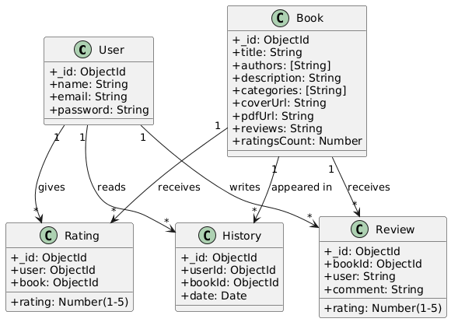
Entities:
- User
- Book
- Rating
- Review
- History
Relationships:
- One user can rate/review many books.
- One book can have many ratings/reviews.
- Each user has a reading history linked to multiple books.

ER DIAGRAM
User ↔ Book (via Rating, Review, History)

DATABASE SCHEMA
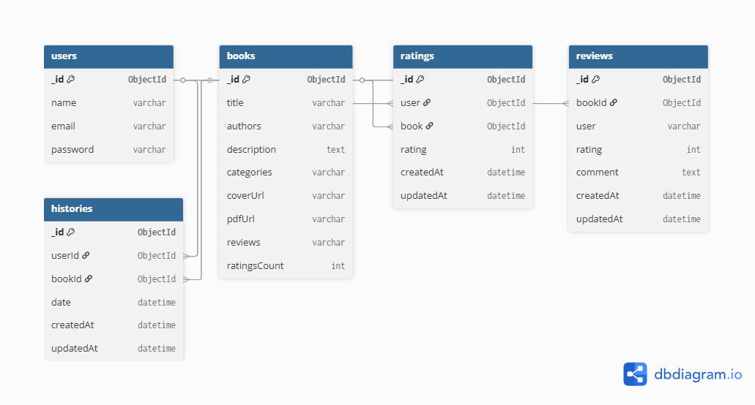
User Collection:
Field | Type
name | String
email | String
password | String
Book Collection:
Field | Type
title | String
authors | Array
pdfUrl | String
coverUrl | String
averageRating | Number

Rating Collection:
| userId | ObjectId |
| bookId | ObjectId |
| rating | Number |
Review Collection:
| userId | ObjectId |
| bookId | ObjectId |
| comment | String |
History Collection:
| userId | ObjectId |
| bookId | ObjectId |
| date | Date |

IMPLEMENTATION
FRONTEND
Developed using HTML, CSS, and JavaScript for a responsive and smooth UI.
Features:
- Dashboard to list books
- Integrated PDF.js viewer
- Buttons for rating and review submission
- History display section
- Token-based login with LocalStorage

BACKEND
Built using Node.js + Express.js with RESTful APIs.
API Routes:
Endpoint | Method | Description
/api/auth/register | POST | Register new user
/api/auth/login | POST | User authentication
/api/books | GET | Fetch all books
/api/history | GET/POST | Manage reading history
/api/ratings | POST | Submit user rating
/api/reviews | POST | Add book review
Middleware:
- JWT-based Authentication
- Error handling
- Validation

MODULES DESCRIPTION

- Authentication
Handles signup/login using JWT tokens and encrypted passwords.
- Dashboard
Displays available books and links to reader interface.
- Book Reader
Uses PDF.js for reading PDFs online within the web app.
- Ratings Module
Allows users to rate books from 1–5 and updates the average dynamically.
- Reviews Module
Users can write and view comments from other readers.
- Reading History
Tracks each book opened and displays reading date and progress.

TESTING
Testing was conducted via Postman and manual browser tests.
Scenarios tested:
- Login / Register Validation
- History addition
- Rating/Review submission
- Data persistence in MongoDB
Result: All modules functioned correctly and passed test cases.

RESULTS

The Readify system successfully achieved its objectives.
- Users can read books directly in browser.
- Ratings & reviews are instantly reflected.
- History logs enable re-accessing previously read books.
- Secure backend ensures safe user data handling

FUTURE ENHANCEMENTS
- AI Recommendation System – suggest books based on reading history.
- Admin Dashboard – manage books and user data.
- Bookmarks & Notes – save reading progress.
- Cloud Deployment – accessible from anywhere.
- Dark Mode UI – better reading experience.

CONCLUSION
Readify demonstrates a complete integration of frontend, backend, and database technologies. It provides a practical and user-friendly platform for online reading, complete with authentication, ratings, reviews, and history tracking.
It stands as a solid base for future scalability and advanced AI-driven features.

REFERENCES
- Node.js Official Documentation – https://nodejs.org
- Express.js API Reference – https://expressjs.com
- MongoDB Manual – https://www.mongodb.com/docs
- Mozilla Developer Network (MDN) – HTML, CSS, JS Guides
- PDF.js Library Documentation – https://mozilla.github.io/pdf.js

